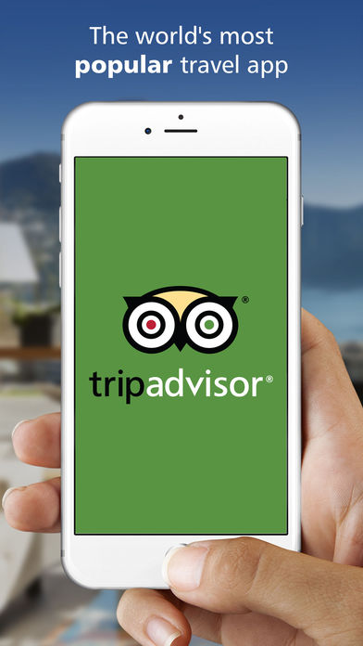

1. Simple slick looking welcome page, animated, logo should fade in. try to make every action in the app animated so cool esthetics and visually pleasing

-Logo

-motto ‘one download…..”

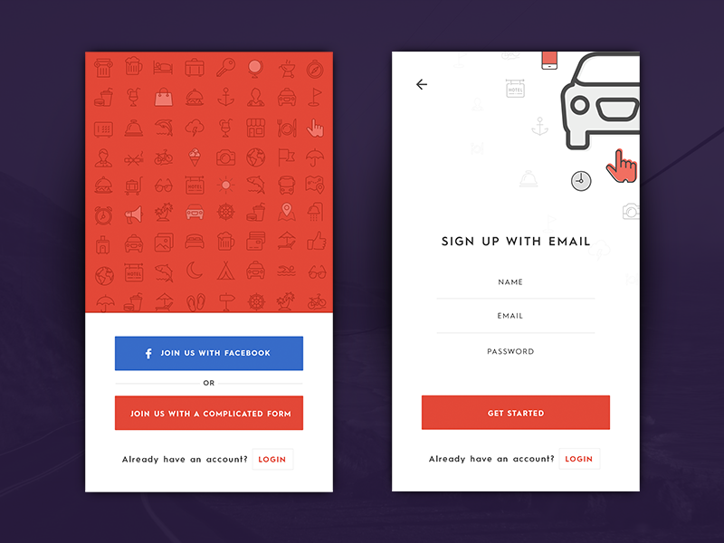

2. then log in page have a facebook, and gmail button and then a join us by signing up with email. Once you click facebook or gmail obviously it would take you within those apps and ask for permission and then once granted then it would take you back into our app.

\*\*\* if it’s a vendor then there would be a box they would need to check and that would be a different sign up process

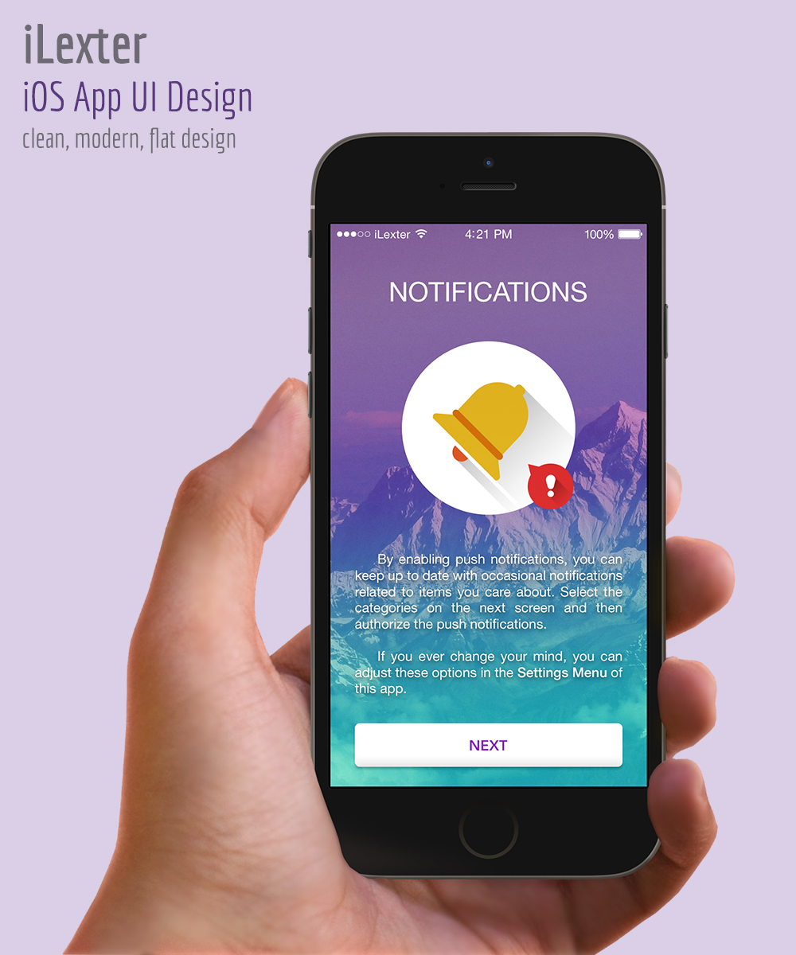

Allow push notification

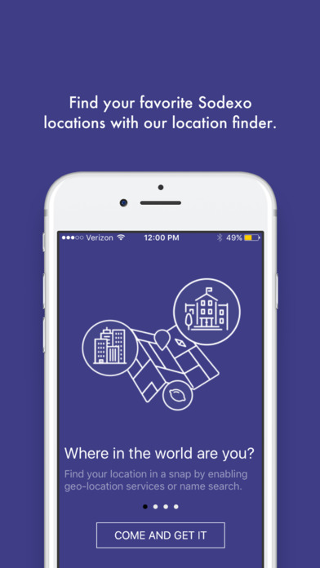

allow location service

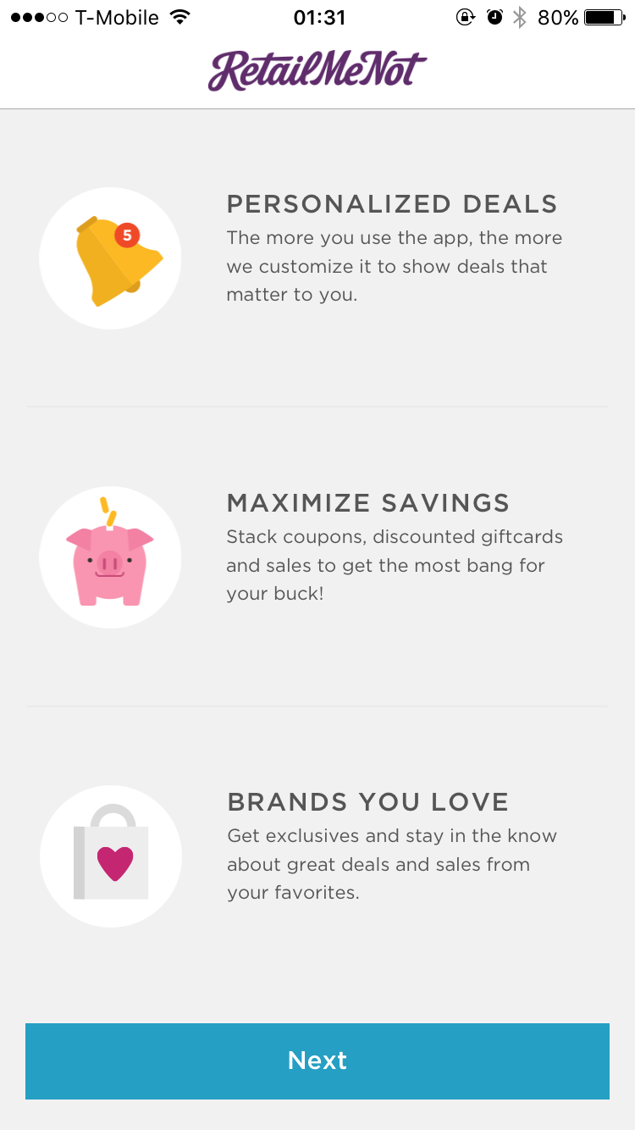

highlight three features

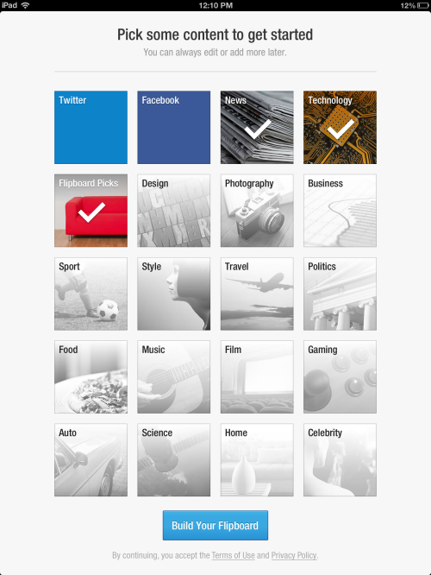

These would be slick looking png icons for different categories so they get to pick what they want to receive coupons from, bars, restaurants, nightlife etc. once they have selected main categories then itll take you to subcategories of your main categories so food would have seafood, Italian, indian etc. night life would be – bars, pubs, club, disco, etc.

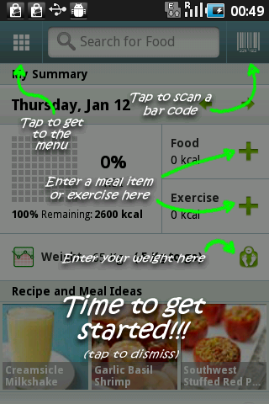

Once on main page then it would show you which button does what and where they can find what

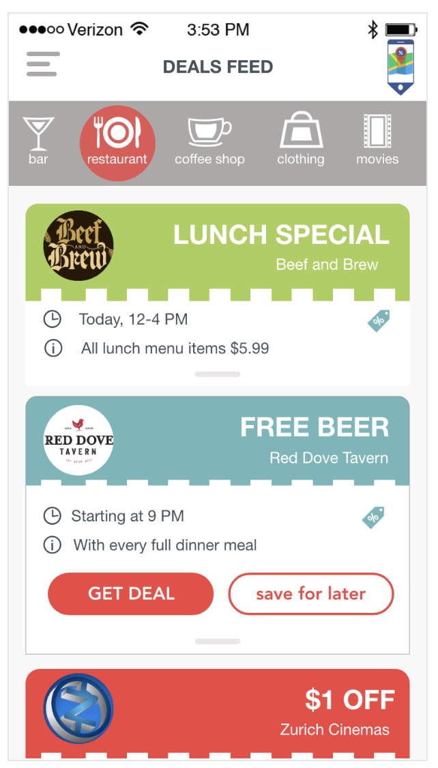

youd be able to pick your coupon categories on top

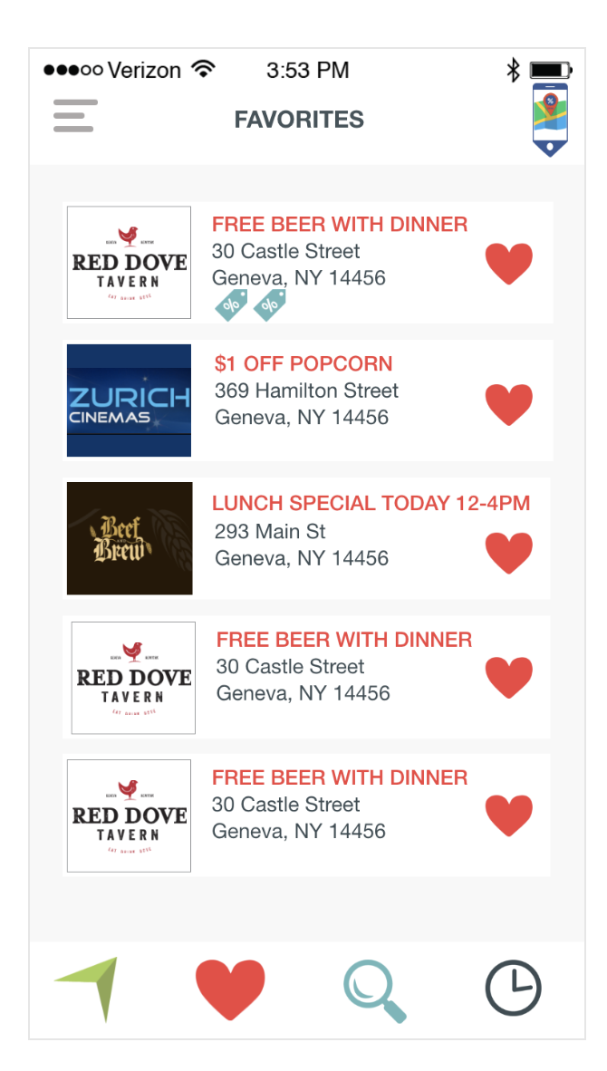

but also pick deals near you and search for them by the icons on the bottom and there should be an activity feed icon as well on the bottom where you can see what your friends redeemed like in the image below with venmo and you can save coupons for later as well.

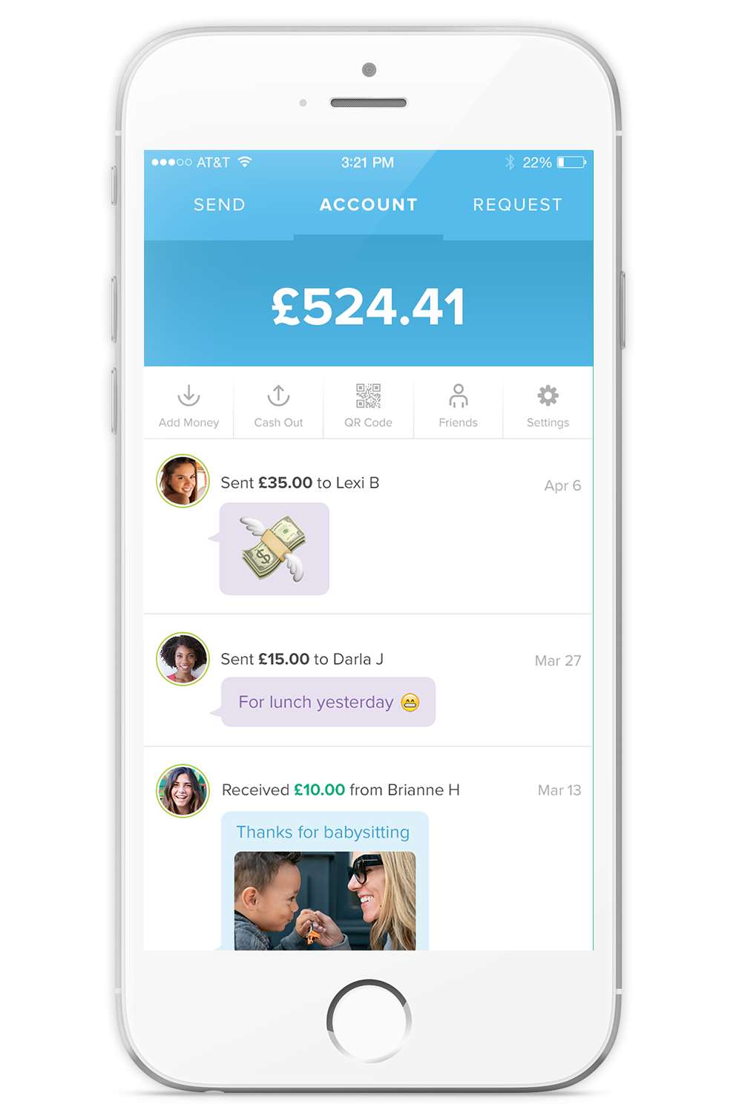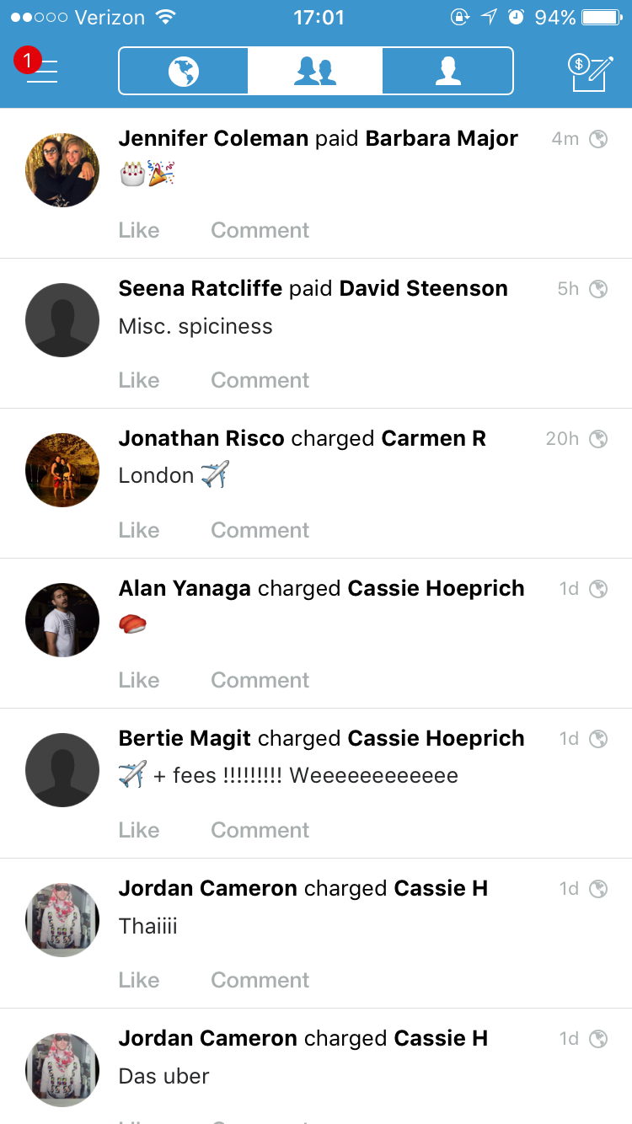

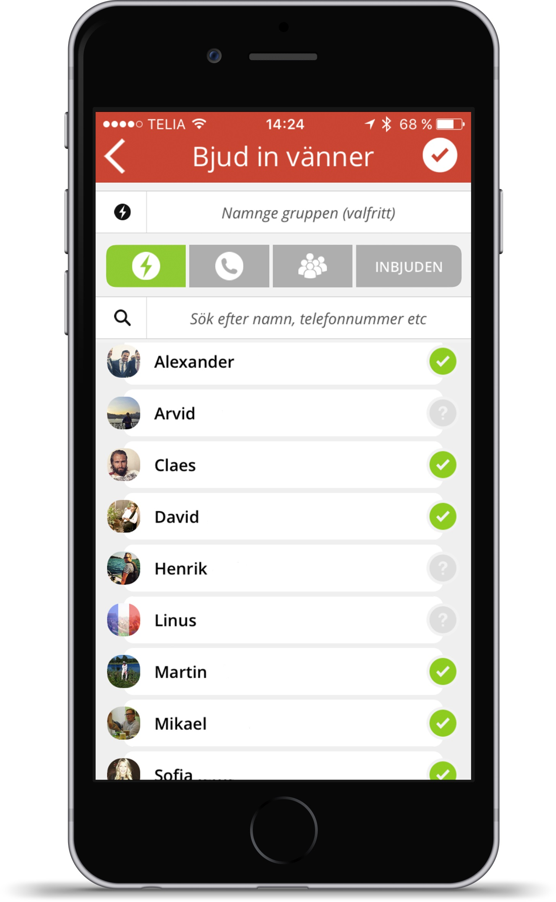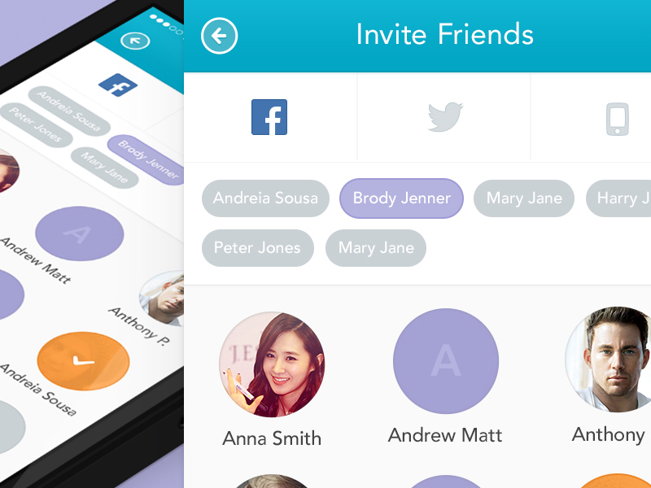

there would be a aspect where youd be able to invite your friends for special deals or share deals with your friends since fb contacts are imported and your contact list from your phone.

Also create friend circles like “drinking group deals” “dinner group circle” etc

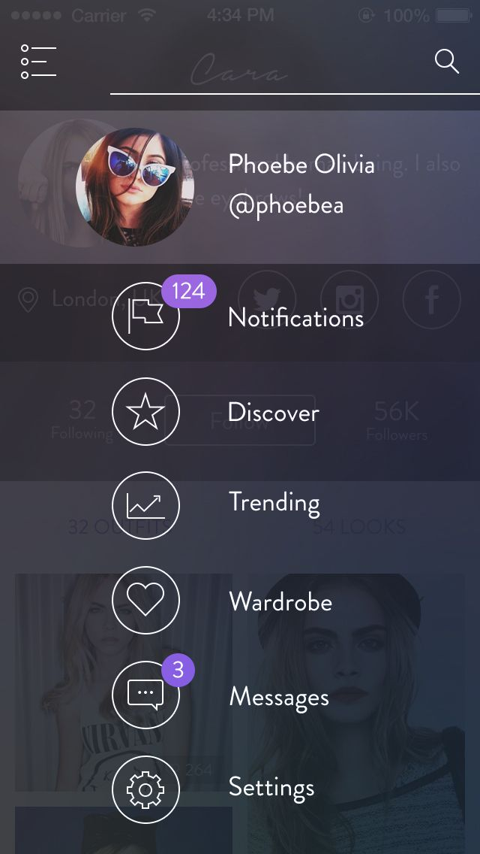

there would be a menu button that would show you your profile picture and username and bunch of menu optiosn below it.

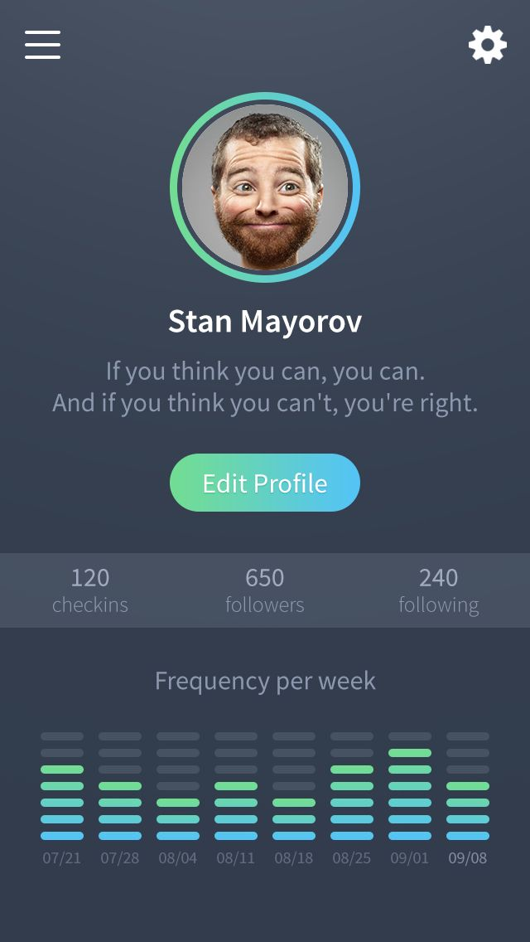

friends can see how many coupns you redeemed and shared and how much money you saved and also there would be a ranking so gamification aspect where youd see your friends and most points for sharing or redeeming and this way people can earn points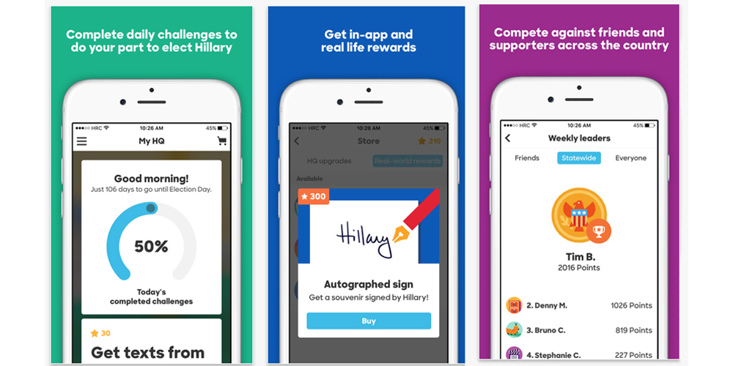

However when vendor clicks the box in sign up they’ll be able to upload coupons via the website and design them or in the app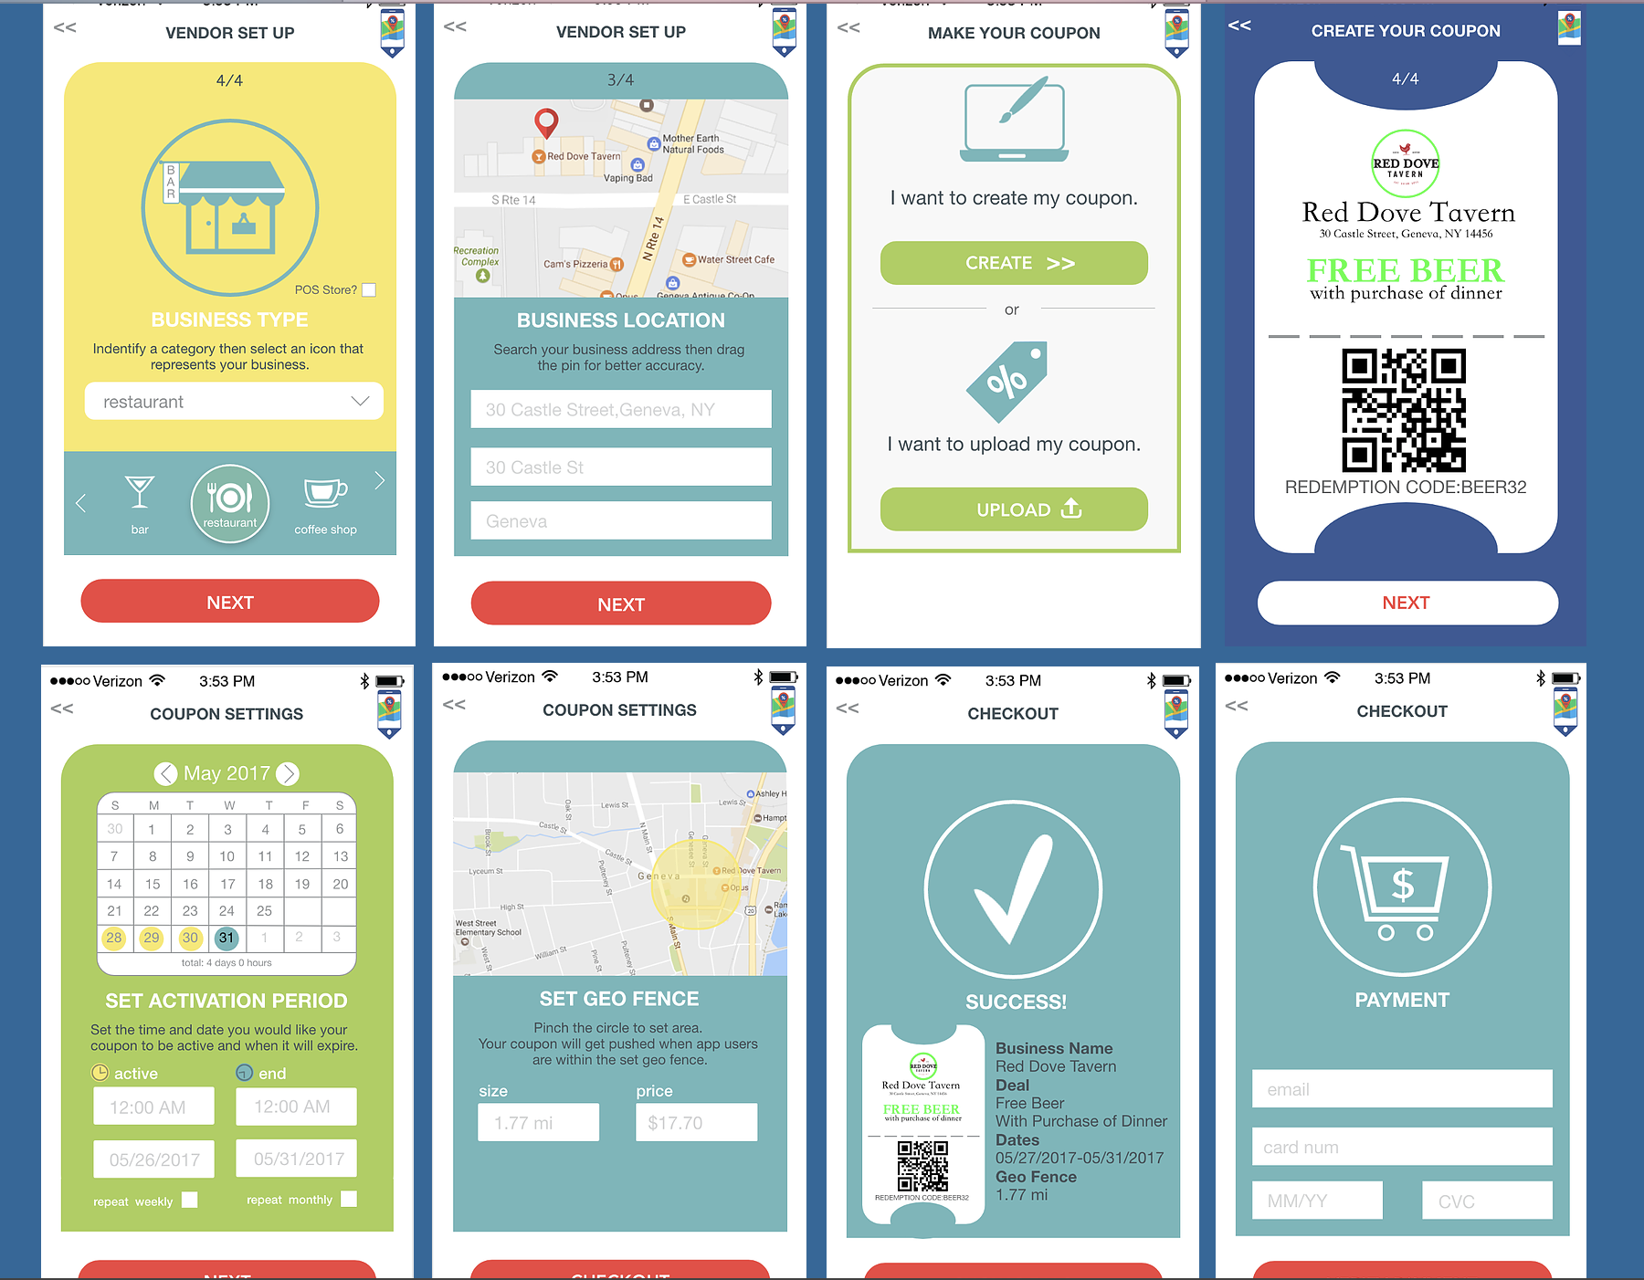.

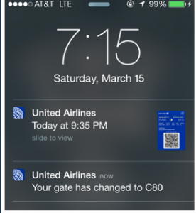

for push notification itd display the coupon as well and not just the text

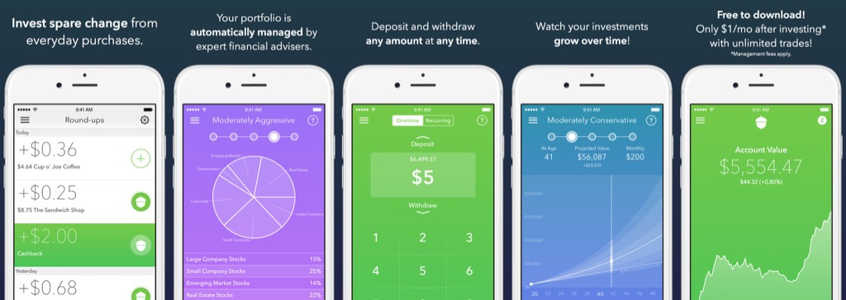

I want the design to be like this very easy for eye to see just skinny lines and plain background rather than bunch of bulk buttons and etc. this is visually pleasing neat and simple.